My Nature Journal

February 10, 2020
Introduction to My Journal (personal remarks about their adventure)
My Picture
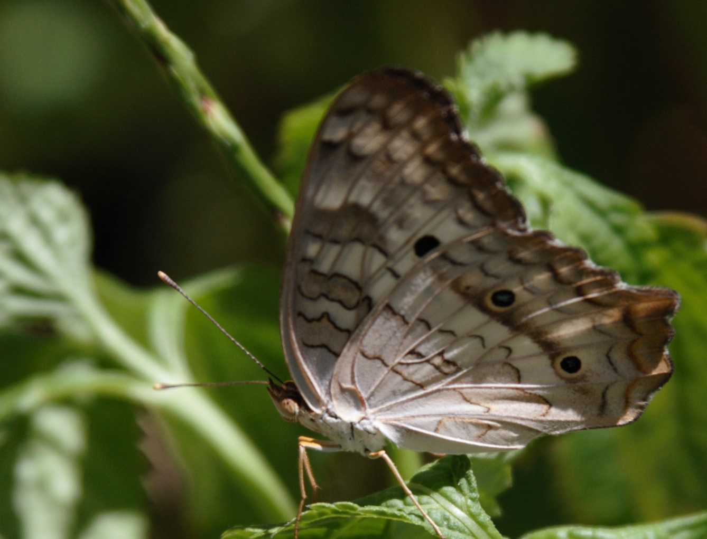
What I found out about my Plant/Bug/Bird/Mammal etc.
What is its Latin name? ___________________________________________________
Where is its Native Habitat? ___________________________________________________
What did you find to be most interesting about your find? _____________________________
__________________________________________________________________________

